

**SEP 780 – Advanced Robotics and Automation**

**Winter 2023**

**Autonomous Swarm Robots Proposal**

**Group 4**

|  |  |
| --- | --- |
| **Member Name** | **Student Number** |
| Meet Patel | 400486035 |
| Jay Patel | 400175525 |
| Vichal Daliya | 400485779 |
| Tushar Bhuva | 400486950 |
| Nikulkumar Dabhi | 400490758 |
| Het Shukla | 400490742 |

**Table of contents**

**1.0 Int****roduction: 2**

**1.1 Problem Statement:** **2**

**2.0 Detailed Functionality:** **2**

**2.1 Brief about project:** **2**

**2.2 Tools and technologies to be used****: 3**

**2.3 Additional features:** **4**

**2.4 Flowchart:** **5**

**2.5 Future scope and application in the Industry:** **5**

**3.0 Project timeline and deliverables:** **6**

**4.0 Tasks distribution among members:** **7**

**5.0 Project Risk****: 7**

**1.0 Introduction:**

**1.1 Problem Statement:**

**Autonomous Multi-Robot System for performing large, slow and risky tasks efficiently.**

**Definition:-**

Build an autonomous multi-robot system popularly known as swarm robots is being built for performing the slow and risky tasks more efficiently than the humans in which the robots communicate and coordinate among themselves through their artificial swarm intelligence to complete the given end task.

**Objective:-**

The objective of our project is to build a small autonomous robot whose behavior can be traced from swarm intelligence. The robot is either controlled by a master control robot or can take its own simple self - decision automatically.

**2.0 Detailed Functionality:**

**2.1 Brief about projet:**

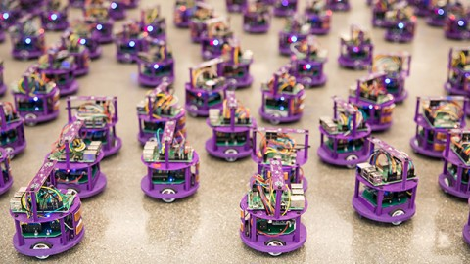

This unmanned ground multi-robot system will implement the solution by first building two mobile robots using **Arduino Unos** and **IR sensors**. From the two robots, one robot will act as master robot and the other robot will act as a slave robot. And here the master robot finds the path for completing the end task autonomously and then it communicates with the slave robot by sending a signal to follow and complete the given end tasks in a cooperative way, Therefore the way of communication between the two swarm robots is called **master and slave communication.**

**2.2 Tools and technologies to be used:**

**TOOLS**

* Arduino - 2 Nos.
* RF Transmitter and Encoder Module - 1 No.
* IR Sensors 2 Nos.
* Arduino UART cable - 1 No.
* L239D Motor Driver Circuit - 2 Nos.
* DC motors - 4 Nos.
* Wheels for Motors - 4 Nos.
* Castor Wheels - 2 Nos.
* Chassis - 2 Nos.
* U Clamps - 4 Nos.
* Wire stripper
* Screwdriver
* Connecting wires
* Battery (9V)

**TECHNOLOGIES**

* Arduino IDE
* Python3 Programming Language
* C Programming Language
* C++ Programming Language
* Machine Learning & Computer Vision (For Future Scope)
* Robotics

**2.3 Additional features:**

With the successful completion of the autonomous multi-robot system project, it is now proposed to extend its capabilities by incorporating the ability to detect gas leaks. To achieve this, the system will be equipped with MQ 135 Gas Sensors on both the master and slave robots. The master robot will be responsible for detecting gas leaks through its sensors and then communicating the location to the slave robots. The slave robots will then move alongside the master robot as a backup, to the location to reconfirm the presence of a gas leak.

This application of the robot system will be particularly useful in hazardous industries where machinery or connections are placed in difficult or dangerous to reach areas. By using the swarm robot system, the process of detecting gas leaks can be made safer and more efficient as the robots can reach areas that are not accessible to humans. Furthermore, the use of multiple sensors in the slave robots will help ensure the accuracy of the leak detection.

In conclusion, the implementation of the gas leak detection capability will greatly enhance the functionality and versatility of the autonomous multi-robot system, making it a valuable tool for various industries that require hazardous area inspections.

**2.4 Flowchart:**

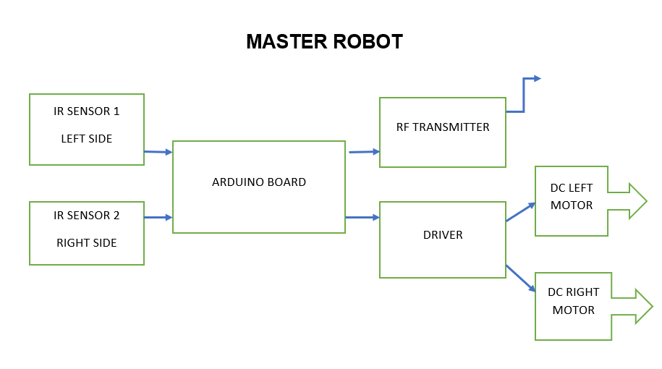

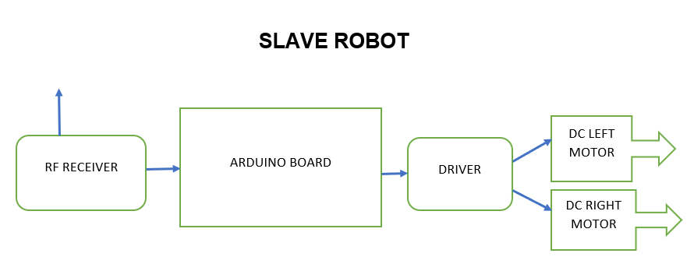

**2.5 Future scope and application in the Industry:**

The potential for this autonomous multi-robot system is vast and has the potential to revolutionize the way large, slow, and risky tasks are performed. This project is just the beginning and there are several areas where it can be expanded in the future.

Some of the areas of future scope are:

* Expansion of the Swarm: The current system consists of only two robots, but the number of robots in the swarm can be expanded to increase the efficiency of the task completion. The communication protocol between the robots can be optimized to handle a larger number of robots.
* Enhanced Decision Making: Currently, the robots can take simple self-decisions or be controlled by a master control robot. The decision-making capabilities of the robots can be enhanced by incorporating more sophisticated algorithms and sensors.
* Integration with other Systems: This system can be integrated with other autonomous systems such as drones and underwater robots to perform complex tasks. This will increase the scope of the tasks that can be performed by the system.
* Advanced Sensing and Mapping: The robots can be equipped with advanced sensors such as LIDAR or stereo cameras for better navigation and mapping capabilities. This will improve the accuracy and efficiency of the task completion.
* Application in Various Industries: The system has the potential to be used in various industries such as construction, mining, agriculture, and disaster response. The versatility of the system can be increased by developing specialized robots for each industry.

In conclusion, the autonomous multi-robot system is a promising solution for performing large, slow, and risky tasks in an efficient manner. With the advancements in technology, the potential for this system is immense and has the potential to revolutionize the way we approach tasks in various industries.

**3.0 Project timeline and deliverables:**

The project Gantt Chart is illustrated below to show the detailed timeline with major tasks the team would need to achieve over the project period by all team members on working with different tasks as distributed, starting from 13 February and ending on 10 April, 2023. Final report, project model and demonstration video will be delivered in the end of the project.

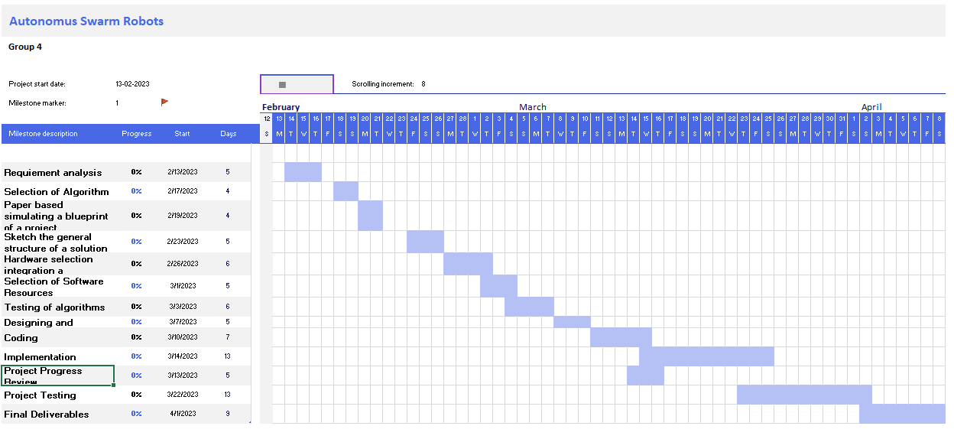

[**LInk of the Gannt chart**](https://docs.google.com/spreadsheets/d/1wNnOjB8TX_yNpySM9-HvxPFUd3S7-fJ1qgdLw9qyYF8/edit?usp=sharing)

**4.0 Tasks distribution among members:**

|  |  |  |
| --- | --- | --- |
| **Task Number** | **Task Name** | **Team Member Responsible** |
| 1 | Requirement Analysis | Meet , Vichal , NIkul |
| 2 | Selection of Algorithm | Jay, Tushar, Het |
| 3 | Paper based simulating a blueprint of a project | Vichal, Het , Nikul |
| 4 | Sketch the general structure of a solution | All Members |
| 5 | Hardware selection integration a Synchronization | Meet, Jay, Tushar |
| 6 | Selection of Software Resources | Meet , Nikul |
| 7 | Testing of algorithms | Vichal, Tushar |
| 8 | Designing and Building GUI | Jay, Het |
| 9 | Coding | Meet , Jay |
| 10 | Implementation | Vichal , Nikul ,Het |
| 11. | Testing | All Members |
| 12. | Final Deliverables | All members |

**5.0 Project Risk:**

1. **Technical Risks:**

* Failure of hardware components such as motors, IR sensors, RF Transmitter and Encoder Module, etc.
* The challenge of creating an effective communication protocol between the master and slave robots.
* Lack of robustness in the system, leading to unreliable performance in real-world environments.

1. **Resource Risks:**

* Availability and timely delivery of hardware components, leading to delays in the project timeline.
* Shortage of technical expertise and manpower, leading to reduced efficiency and effectiveness in the development process.

1. **Budget Risks:**

* Unforeseen costs associated with hardware and software components, leading to budget overruns.

1. **Market Risks:**

* Competition from similar products and services in the market, leading to reduced demand for the proposed system.
* Slow adoption of autonomous multi-robot systems in the target market, leading to low demand for the product.

1. **Regulatory Risks:**

* Changes in laws and regulations related to autonomous systems, leading to the need for changes in the system design and development process.

Overall, the autonomous multi-robot system project involves significant technical, resource, budget, market and regulatory risks, which need to be carefully managed and mitigated to ensure the success of the project.